**Assignment 4 Template**

**LAST NAME: Yuan**

**FIRST NAME: Feng**

**USERID: y87feng**

**UWaterloo ID:20600787**

**Problem 1: Fill in the information below based on your data which were generated using your ID number as the seed for the random number generator.**

**model = 1 mu = 7 sigma = 8**

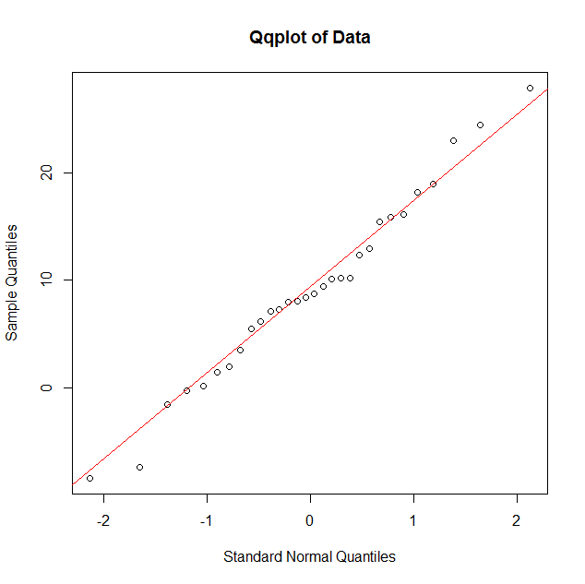

**In this qqplot the data fits the Gaussian model very well, since the nearly all the points are very close to the red line. But the number of point is few, we need more points to justify.**

**mu0 = 8**

**Insert the output of the command** t.test(y,mu=mu0,conf.level=0.95)

**One Sample t-test**

**data: y**

**t = 0.71453, df = 29, p-value = 0.4806**

**alternative hypothesis: true mean is not equal to 8**

**95 percent confidence interval:**

**5.903023 12.348977**

**sample estimates:**

**mean of x**

**9.126**

**Obtain the following information from this output:**

**value of test statistic for testing H: mu = mu0 is: 0.71453**

**degrees of freedom of t distribution =29**

**p-value for testing H: mu=mu0 equals 0.4806**

**95% confidence interval for mu is: [5.903023,12.348977]**

**Insert your conclusion regarding H: mu=mu0 here.**

**The p-value for testing H : mu=mu0 equals 0.4806 > 0.1, which has no evidence to against the hypothesis.**

**sample mean = 9.126**

**sigma0 = 10**

**sample variance = 74.49916**

**p-value for testing H: sigma = sigma0 equals 0.3276376**

**Insert your conclusion regarding H: sigma=sigma0 here.**

**The p-value for testing H : sigma=sigma0 equals 0.3276376 > 0.1, which has no evidence to against the hypothesis.**

**95% confidence interval for sigma squared:[47.25214,134.6336]**

**95% confidence interval for sigma:[6.874019,11.60317]**

**Problem 2: Fill in the information below based on your data which were generated using your ID number as the seed for the random number generator.**

**alpha = -1.59646 beta = 0.6230531 model = 1**

**sample correlation = 0.1933071**

**Insert the output of the command** Summary(RegModel)

**Call:**

**lm(formula = y ~ x)**

**Residuals:**

**Min 1Q Median 3Q Max**

**-28.9824 -7.2305 0.5727 7.8869 27.1870**

**Coefficients:**

**Estimate Std. Error t value Pr(>|t|)**

**(Intercept) 0.1979 2.5469 0.078 0.938**

**x 0.3898 0.1999 1.950 0.054 .**

**---**

**Signif. codes: 0 ‘***’ 0.001 ‘**’ 0.01 ‘*’ 0.05 ‘.’ 0.1 ‘ ’ 1**

**Residual standard error: 10.74 on 98 degrees of freedom**

**Multiple R-squared: 0.03737, Adjusted R-squared: 0.02754**

**F-statistic: 3.804 on 1 and 98 DF, p-value:** **0.05398**

**Obtain the following information from this output:**

**estimate of the intercept = 0.1979**

**estimate of the slope = 0.3898**

**degrees of freedom of t distribution =98**

**value of test statistic for testing H: no relationship (slope = 0) equals 1.950**

**p-value for testing the H: no relationship (slope = 0) equals 0.05398**

**Insert your conclusion regarding the hypothesis of no relationship here.**

**The p-value for testing H : no relationship (slope = 0) equals 0.05 < 0.05398**

**< 0.1, which has weak evidence to against the hypothesis.**

**estimate of sigma = 10.74079**

**95% confidence interval for the slope: [-0.006802203,0.786403]**

**90% confidence interval for the mean response at x=5: [ -0.6662196,4.959936]**

**99% prediction interval for the response at x = 2 : [27.81889 ,29.7738 ]**

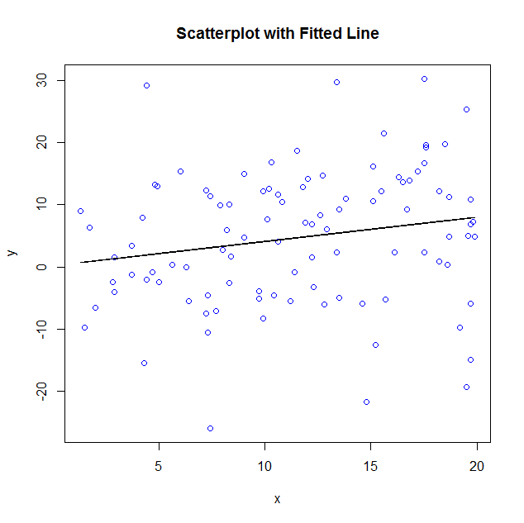

**in this plot, many points are disperse randomly, so it is not linear relationship between x and y.**

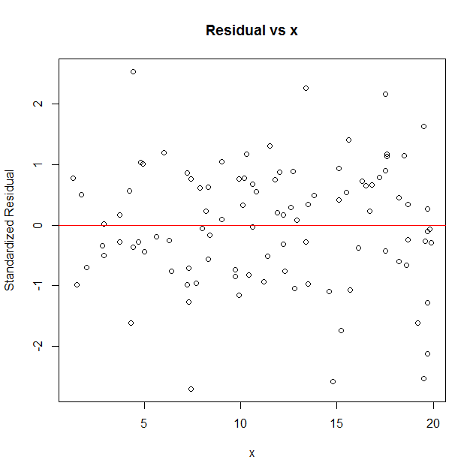

**The points in a residual plot are randomly dispersed around the horizontal axis,so it is a linear relationship between x and residual.**

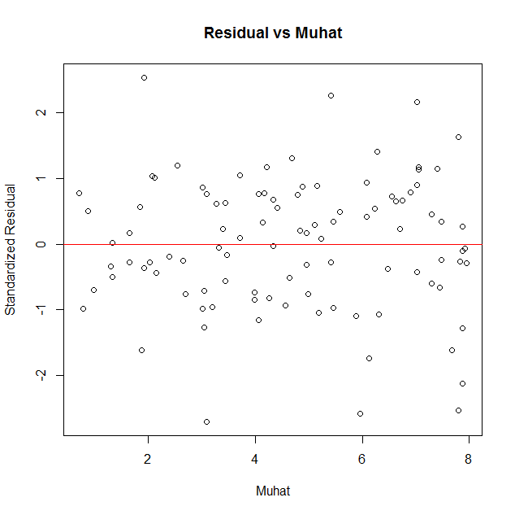

**The points in a residual plot are randomly dispersed around the horizontal axis,so it is a linear relationship between Muhat and residual.**

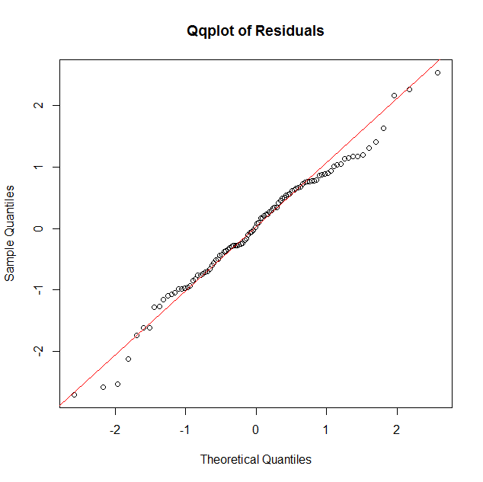

**In this qqplot the data fits the Gaussian model very well, since the nearly all the points are very close to the red line.**

**Based on the scatterplot with fitted line and the residual plots discuss the fit of the simple linear model to your data. Be sure to comment on each plot. Indicate clearly what you expect to see for each plot if the model assumptions hold and what you observe for your data.**

**Problem 3: Fill in the information below based on your data which were generated using your ID number as the seed for the random number generator.**

**mu1 = -1.710907 mu2 = -1.633187 sigma = 8**

**Insert the output of the command**

t.test(y1,y2,mu=0,var.equal=TRUE,conf.level=0.95)

**Two Sample t-test**

**data: y1 and y2**

**t = 0.91698, df = 63, p-value = 0.3627**

**alternative hypothesis: true difference in means is not equal to 0**

**95 percent confidence interval:**

**-2.268917 6.116917**

**sample estimates:**

**mean of x mean of y**

**0.168**  **-1.756**

**From this output obtain the following information:**

**The value of the test statistic for testing H: mu 1= mu2 equals 0.91698**

**degrees of freedom of t distribution = 63**

**p-value for testing H: mu1=mu2 equals 0.3627**

**Insert your conclusion regarding H: mu1=mu2 here.**

**The p-value for testing H : mu1=mu2 equals 0.3627 > 0.1 which has no evidence to against the hypothesis.**

**95% confidence interval for the difference in means: [-2.268917,6.116917]**

**sample means:**

**y1bar = 0.168**

**y2bar = -1.756**

**sample standard deviations:**

**s1 = 7.617481**

**s2 =9.070923**

**pooled estimate of sigma = 8.433051**

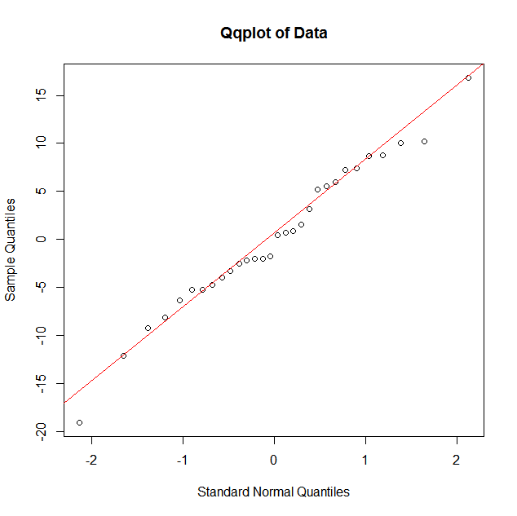**In this qqplot the data fits the Gaussian model very well, since the nearly all the points are very close to the red line. But the number of point is few, we need more points to justify.**

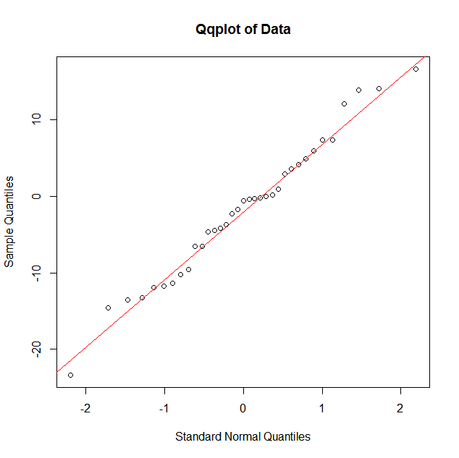

**In this qqplot the data fits the Gaussian model very well, since the nearly all the points are very close to the red line. But the number of point is few, we need more points to justify.**